Logan Watanabe

67-328

Assignment 3

<https://blank-cawobu.backliftapp.com/three/index>

For the assignment this week I made a webpage that loads the NFL teams from two JSON files.

1.Ajax Requests: Information from Sever

The AFC file (afc.json) is loaded with $.getJSON() and is initiated by clicking the “Generate AFC” button. The NFC file (nfc.json) is loaded using a XMLHttpRequest and is initiated by clicking the “Generate NFC” button. In the process of loading these two files, I formatted the data of each team to be separated according to their “division” attribute/tag. Using a couple for loops I was able to create several html lists with the teams by division, which I then posted on the page.

2. Dynamically Update Web Page Content from Reply

In receiving the data from the server I also applied several ids and classes to the elements so that I could manipulate the DOM and do stuff to it.

For example, using the class “afc_div” and either “north”, “south”, “east”, or “west” I was able to color coordinate the different divisions between both leagues by clicking the “Color!” button. Another example is in me targeting the buttons using is tags (ie $(“#colorize”)) to find DOM elements to manipulate. Other examples of me selecting elements is with the “find()” function, using html tags, and also using the “:contains()” function to find html content.

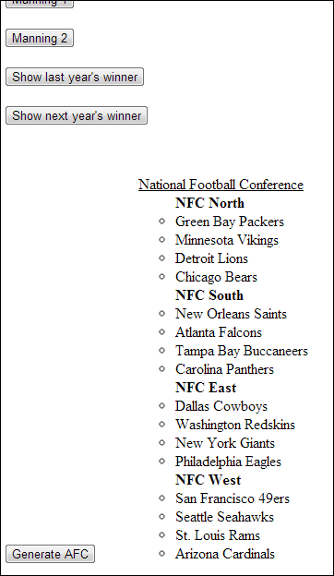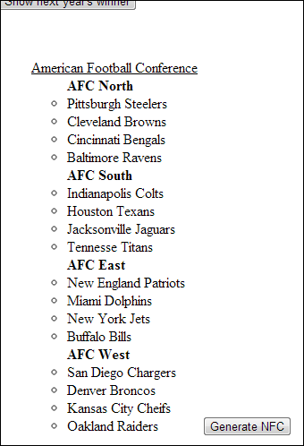

10 different methods for manipulating DOM:

html(): This html() method is used within the getJSON block of text to place some html text into a specified area. In this case it is the area corresponding to the JSON output.

fadeToggle(): The button labeled “logo” will cause the nfl logo on the top of the page to fade in or out. It does this by using the fadeToggle() function. I can’t provide a screenshot because it fades too fast.

hide(): For many of the buttons I used the hide() method to remove any button after they performed their actions. For example, both the “afc” and “nfc” buttons are hidden after they are clicked to prevent the data from reloading.

slideToggle(): For each of the divisions listed under the NFC and AFC can be expanded and compressed based on division by clicking on the division title (ie “AFC North”). This is done by using the slideToggle() function on the <li> elements in each <ul> that is clicked (see screenshot below).

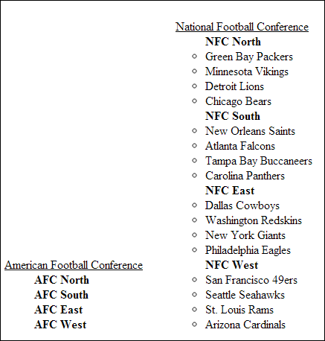

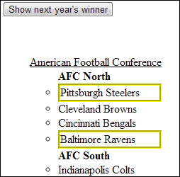

show() & addClass() & css(): When you click the “show next year’s winner” or “show last year’s winner” the show() method is used on the relevant list elements to make sure they are not hidden. Then, the css() method changes the border around the element to be yellow and bolded. And finally the addClass() method adds a “champ” class to the element (see screenshot above).

css(): Another instance of the css() method is used when the “Color!” button is pressed, and the background-color of the divisions within the list are assigned different colors. 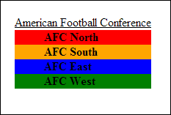

ReplaceWith(): The “Color!” button uses the replaceWith() method to remove the button and insert the text “Colored!” where the button used to be (see screenshot below).

insertBefore(): The “Manning 1” button uses insertBefore() to insert a picture of Peyton Manning before the button. Although the button is subsequently removed, the image would show up before the button element (see screenshot below).

insertAfter(): The “Manning 2” button uses insertAfter() to insert a picture of Eli Manning before the button. Although the button is subsequently removed, the image would show up after the button element (see screenshot below).

